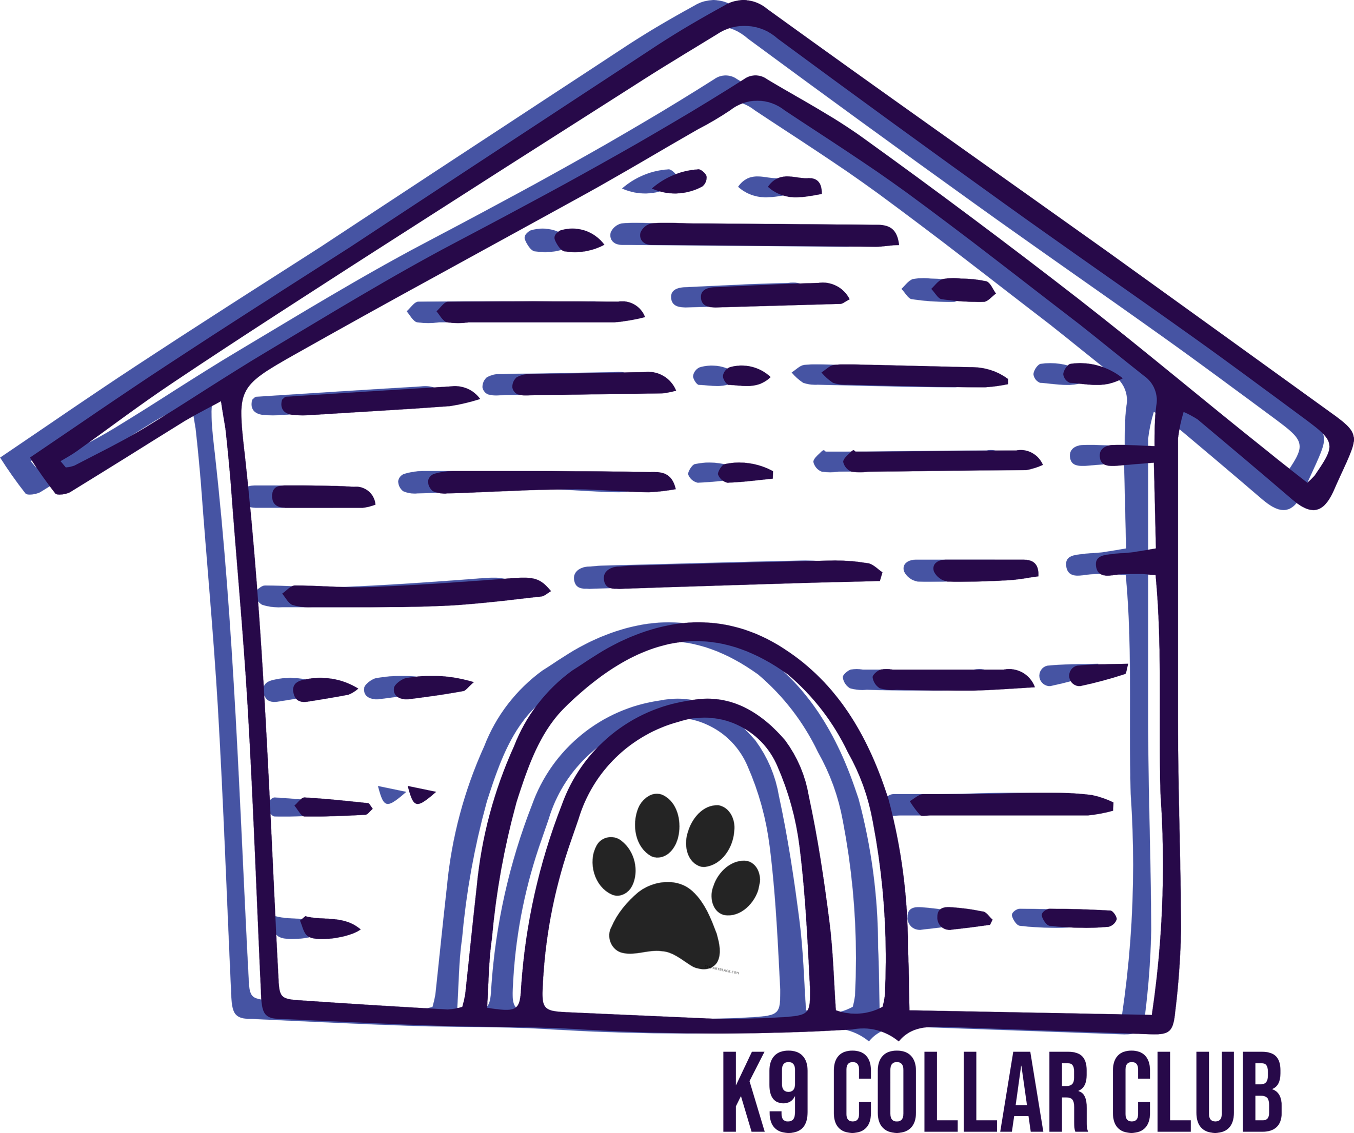

K-9 Collar Club
Party Guest Information

Pet Owner’s name: Today’s Date:
Address:

( ) ( )
Primary Phone Number Secondary phone number

Email Address

Dog’s name Dog’s Age

Sex: Spayed/Neutered:
M F Yes No

Name of the party you’re attending:
Party date:

Authorization of Medical Care: Dogs attending parties are involved in a variety of activities throughout the day. This includes running, climbing on and jumping off playground equipment, and rough housing with their canine buddies. Despite our best efforts, accidents may and will occasionally occur, and injury may result. Owner(s)/Guardian understand and accept the risk and agree that K9 Collar Club, it’s employees, officers, and owners will not be held responsible for any injury. Owner(s)/Guardian authorize K9 Collar Club to seek emergency treatment for any injury deemed an emergency but agree that if they are unsuccessful in contacting me; emergency care will not be delayed. All cost for veterinary care from injuries or illness is the (pet owner’s) responsibility.

Vaccination and Medical Information: Owner(s)/Guardian confirms the dog(s) has not been exposed to any infectious disease to their knowledge in the last 30 days. Owner(s)/Guardian is aware the dog(s) cannot attend the party if they are feeling ill in the last 24 hours. Owner(s)/Guardian also confirms the dog(s) is up-to-date on the list of vaccines/preventative care below and will provide a copy of Veterinary records upon arrival of the party.
- Rabies
- Distemper
- Parvo
- Bordetella
- Leptospirosis
- Flea and Tick Prevention
- Annual Intestinal Parasite Testing

Photo Release: Owner(s)/Guardian authorizes use of photographs and/or videos of their dog(s) on K-9 Collar Club’s social media accounts such as Instagram, Facebook, news reports, and other social media.

Right to Decline: Owner(s)/Guardian understands that K-9 Collar Club reserves the right to terminate or decline participation in activities with K-9 Collar Club at any given time.
Acknowledgement: These policies contain the entire agreement between the parties. All terms and conditions of this agreement shall be binding between Owner(s)/Guardian, K-9 Collar Club employees and administrators, and personal representatives.

____________________________________ ______________
Pet Owner’s Signature Today’s Date

